First National Thanksgiving - October 20, 1864 for the fourth Thursday in November by President Abraham Lincoln. Each subsequent year the president followed his example.

“It has pleased Almighty God to prolong our national life another year, defending us with His guardian care against unfriendly designs from abroad, and vouchsafing to us in His mercy many and signal victories over the enemy, who is of our own household. It has also pleased our Heavenly Father to favor our citizens in their homes, as our soldiers in their camps, and our sailors on our rivers and seas, with unusual health. He has largely augmented our free population by emancipation and immigration, while He has opened to us new sources of wealth, and has crowned the labor of our workingmen in every department of industry with abundant rewards. Moreover, He has been please to animate and inspire our minds with fortitude, courage and resolution sufficient to the great trial of civil war into which we have been brought by our adherence as a nation to the cause of freedom and humanity, and to afford us reasonable hopes of an ultimate and happy deliverance from all our dangers and afflictions.

Now, therefore, I, Abraham Lincoln, President of the United States, do hereby appoint and set apart the last Thursday of November next as a day which I desire to be observed by all my fellow citizens, wherever they may be, as a day of thanksgiving and praise to Almighty God, the benificent Creator and Ruler of the Universe. And I do further recommend to my fellow citizens aforesaid, that, on that occasion, they do reverently humble themselves in the dust, and from thence offer up penitent and fervant prayers and supplications to the Great Disposer of events for a return of the inestimable blessings of peace, union, and harmony throughout the land which it has pleased Him to assign as a dwelling-place for ourselves and our posterity throughout all generations.”

First Act of Congress for an Annual Thanksgiving Day
the fourth Thursday of November - 1941.

The First Thanksgiving

Psalm 136

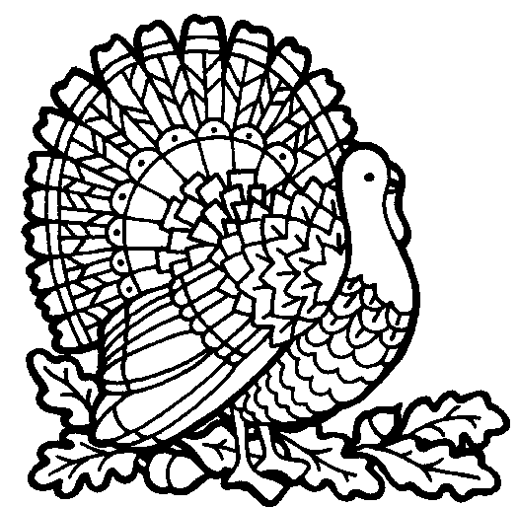

Mayflower Compact - November 11, 1620
signed by 41 men aboard the Mayflower.

In Ye name of God Amen.

We whose names are underwritten, the loyall subjects of our dread soveraigne Lord King James, by ye grace of God, of Great Britaine, France, & Ireland king, defender of ye faith, & c.

Haveing undertaken, for ye glorie of God, and advancemente of ye Christian faith and honor of our king & country, a voyage to plant ye first colonie in ye Northerne parts of Virginia, doe by these presents solemnly & mutually in ye presence of God, and of one another, covenant, & combine ourselves together into a Civill body politick; for our better ordering, & preservation & furtherance of ye ends aforesaid; and by vertue hereof to enacte, constitute, and frame such just & equall Lawes, ordinances, Acts, constituions, & offices, from time to time, as shall be tought most meet & convenient for ye generall good of ye colonie: unto which we promise all due submission and obedience.

In witness whereof we have hereunder subscribed our names at Capcodd ye-11-of November, in ye year of ye riagne of our soveraigne Lord King James of England, France, & Ireland ye eighteenth, and of Scotland ye fifie fourth. Ano Dom. 1620.”
First Thanksgiving Feast - October 1621

“They began now to gather in the small harvest they had, and to fit up their houses and dwellings against winter, being all well recovered in health and strength and had all things in good plenty. For as some were thus employed in affairs abroad, others were exercised in fishing, about cod and bass and other fish, of which they took good store, of which every family had their portion. All summer there was no want; and now began to come in store of fowl, as winter approached, of which this place did abound when they came first (but afterward decreased by degrees). And besides waterfowl there was great store of wild turkeys, of which they took many, besides venison, etc. Besides they had about a peck a meal a week to a person, or now since harvest, Indian corn to that proportion. Which many afterwards write so largely of their plenty here to their friends in England, which were not feigned but true reports.” [Morrison, ed. William Bradford, Of Plimouth Plantation, 1620-1647, p. 90]

“Our harvest being gotten in,our Governor sent four men on fouling, that so we might after a more special manner rejoice together, after we had gathered the fruit of our labours. They four in one day killed as much fowl as, with little help beside, served the Company almost a week. At which time, amongst other recreations, we exercised our arms, many of the Indians coming amongst us, and amongst the rest their greatest king, Massasoit with some 90 men, whom for three days we entertained and feasted. And they went out and killed five deer which they brought to the plantation and bestowed on our Governor and upon the Captain and others.” [Mourt’s Relation, from a letter of Edward Winslow to an English friend dated 11 Dec. 1621, Morrison, fn. p. 90]

There were at this time 50 people and 7 dwellings [Byington, The Puritan as a Colonist and a Reformer, pp. 23-25].
“Governor Bradford says: ‘All ye somer there was no wante.’ Their relations with the Indians had become so friendly that Winslow tells us they went about in the woods as safely ‘as in the hieways in England.’”

First Record of a Day of General Thanksgiving
November 25, 1668, by appointment of the Governor.

First Thanksgiving Proclamation - June 20, 1676 - by governing council of Charleston, Massachusetts, celebrated on June 29, 1676.

“The Holy God having by long and Continual Series of his Afflictive dispensation in and by the present Warr with Heathen Natives of this land, written and brought to pass bitter things against his own Covenant people in this wilderness, yet so that we evidently discern that in the midst of his judgements he hath remembered mercy, having remembered his Footstool in the day of his sore displeasure against us for our sins, with many singular Intimations of his Fatherly Compassion, and regard; reserving many of our Towns from Desolation Threatened, and attempted by the Enemy, and giving us specially of late with many of our Confederates many signal Advantages against them, without such Disadvantage to ourselves as formerly we have been sensible of, if it be the Lord’s mercy that we are not consumed, It certainly bespeaks our positive Thankfulness, when our Enemies are in any measure disappointed or destroyed; and fearing the Lord should take notice under so many Intimations of his returning mercy, we should be found an Insensible people, as not standing before Him with Thanksgiving, as well as lading him with our Complaints in the time of pressing Afflictions: The Council has thought meet to appoint and set apart the 29th day of this instant June, as a day of Solemn Thanksgiving and praise to God for such his Goodness and Favour, many Particulars of which mercy might be Instanced, but we doubt not those who are sensible of God’s Afflictions, have been as diligent to espy him returning to us; and that the Lord may behold us as a People offering Praise and thereby glorifying Him; the Council doth commend it to the Respective Ministers, Elders and people of this Jurisdiction; Solemnly and seriously to keep the same Beseeching that being perswaded by the mercies of God we may all, even this whole people offer up our bodies and soulds as a living and acceptable Service unto God by Jesus Christ.”

First Presidential Appointment of a Day of Thanksgiving Thursday, November 26, 1789 by George Washington (also again in 1795).

